

Mathematics Specialist Unit 1

Test 5

Matrices

Name: ______________________ Total Marks:__________

Task type: Response

Time allowed for this task: 60 minutes, in-class, under test conditions
Section One: Calculator-free 30 minutes ( 19marks)
Section Two: Calculator-assumed 30minutes ( 30marks)

Materials required: Calculator with CAS capability (to be provided by the student)

Standard items: Pens (blue/black preferred), pencils (including coloured), sharpener, correction fluid/tape, eraser, ruler, highlighters

Special items: Drawing instruments, templates, notes on one unfolded sheet of
A4 paper, and up to three calculators approved for use in the WACE examinations
Formula sheet

Marks available: 60 marks

Task weighting: 8.5%

Section One : Calculator Free 27 Marks
Time Allowed 30 minutes

Question 1
[7 marks]

Given that $A=\left[\begin{matrix}2 & -1 \\ -5 & 3\end{matrix}\right]$ , $B=\left[\begin{matrix}1 & 0 \\ 3 & -5\end{matrix}\right]$ and $I$ is the $2×2$ identity matrix.

Find
- $A+B$

- $3B$

- $2A – B +I$

- $AB$

- $A^{-1}$

Question 2

[5 marks]
For the matrices

$A=\left[\begin{matrix}0 & 1 \\ 5 & 3 \end{matrix}\begin{matrix}4 \\ 3\end{matrix}\right]$ $B=\left[\begin{matrix}1 & 0 \\ -2 & 4\end{matrix}\right]$ $C=\left[\begin{matrix}5 & -2\end{matrix}\right]$ $D=\left[\begin{matrix}1 & -4 \\ 0 & 1 \\ 6 & -2\end{matrix}\right]$

- Which pairs of matrices can be added?

- Write down all the pairs of matrices that can be multiplied.

- Multiply the two matrices that will give a product that is a square matrix.

Question 3
[4 marks]

Given vectors$a = 2i+7j$and $b=-6i+8j$

Find
- $\left|b\right|$

- $a.b$

- Find the vector projection of $a$ onto $b$

Question 4
[3 marks]
Write the equation of the following graph in the form $y=a\sin\left(bx\right)+d$

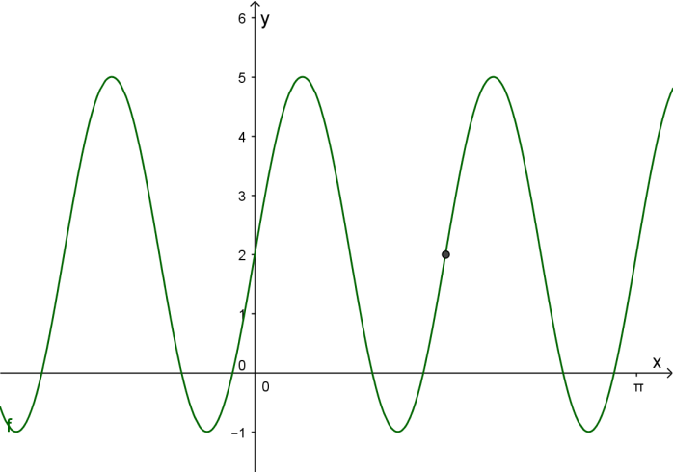

$$(\frac{π}{2},2)$$

Question 5
[8 marks]
- Rewrite the following in terms of matrix $X$

  - $2X+A=B$

  - $AX+BX=C$

  - $XA=B+2X$

- For the non-singular matrices$A$ and $B$ such that $AB=BA$. Show that $A^{2}=BA^{2}B^{-1}$

Section Two : Calculator Assumed 30 Marks
Time Allowed 30 minutes Name:_______________________

Question 6
[5 marks]

- Express $\sin{θ}+5\cos{θ}$ in the form $R\sin{(θ+α)}$ for an acute angle in radians.

- Hence determine the maximum value of $\sin{θ}+5\cos{θ}$and the smallest positive value of $θ$at which this occurs.

Question 7
[4 marks]
A body is acted on by the forces as shown in the diagram.
Find the magnitude and direction of the resultant force.

30°
20 N
15°
30 N

Question 7
[4 marks]

Consider the system of equations:

$$2y=12+x$$
$$2x+3y=17$$

a) Write this system as a matrix equation. (2)

b) Solve the system using matrix methods. (2)

Question 8
[4 marks]
Given that $A=\left[\begin{matrix}x+3 & 5 \\ -2 & -x\end{matrix}\right]$

- Find, in terms of x, the determinant of matrix$A$.

- Find the greatest value of$x$ that makes the matrix$A$ singular.

Question 9
[4 marks]
- Find the $2×2$transformation matrix representing a rotation of 30$°$ anti-clockwise about the origin

- Find the $2×2$transformation matrix representing a rotation of 45$°$ anti-clockwise about the origin.

- Hence, find the transformation matrix that represents a 75$°$ anti-clockwise rotation about the origin.

Question 7
[3 marks]

Use matrices to find the image of the line $x-3y=1$ after it is reflected in the line$y=-x$.

Question 10
[8 marks]
On a normal Monday’s trading, BRASH’S Melville store sell, on average, 8 televisions, 12 music systems and 6 digital video recorders. In comparison, the Cannington store sells, on average, 4 televisions, 9 music systems and 5 digital recorders.

a) Represent this information as the matrix S. (2)

b) The profits ($) on each item can be represented by matrix P, where P = (2)
Calculate SP.

What do the entries tell you?

For their MAD MONDAY SALE, profits were reduced by 40% and the following quantities sold.
Melville : 4 televisions, 6 music systems and 10 digital video recorders
Cannington : 5 televisions, 5 music systems and 6 digital video recorders

c) Use matrix operations to determine the overall increase or decrease in profit for the two stores on MAD MONDAY over a normal Monday. (4)

